

**Independent University, Bangladesh (IUB)**

**School of Engineering and Computer Science Department of CSE**



**COMPUTER ORGANIZATION AND ARCHITECTURE PROJECT REPORT**

**Submitted By:**

|  |  |
| --- | --- |
| Student Names: | **Ariful Islam Shiam,Ahmad Reyad Onik,Taskia Binta Alam** |
| Student ID: | 1710864_1710284_1721863 |
| Section: | 2 |

**Project Information:**

|  |  |
| --- | --- |
| Project No.: | **05** |
| Experiment Name: | Virtual Memory System. |
| Course Name: | Computer Organization and Architecture (COA) |
| Semester: | Summer-2020 |
| Course ID: | 214 |
| Submission Date: | 26/09/2020 |

**Submitted To:**

|  |  |
| --- | --- |
| Name of faculty: | **Mohammad Noor Nabi** |

**Report on VIRTUAL MEMORY SYSTEM**

**Introduction**

**Virtual Memory is a storage scheme that provides user an illusion of having a very big main memory. This is done by treating a part of secondary memory as the main memory.**

**Virtual memory serves two purposes.**

* **First, it allows us to extend the use of physical memory by using disk.**
* **Second, it allows us to have memory protection, because each virtual address is translated to a physical address.**

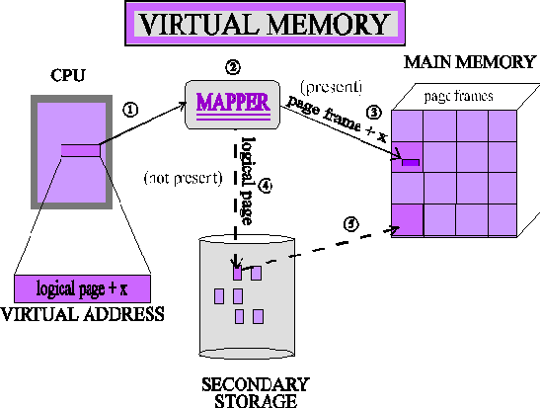

**History of Virtual Memory**

In the 1940s and 1950s, all larger programs had to contain logic for managing primary and secondary storage, such as [overlaying](https://en.wikipedia.org/wiki/Overlay_(programming)). Virtual memory was therefore introduced not only to extend primary memory, but to make such an extension as easy as possible for programmers to use.[[5]](https://en.wikipedia.org/wiki/Virtual_memory#cite_note-denning-6) To allow

for [multiprogramming](https://en.wikipedia.org/wiki/Multiprogramming) and [multitasking](https://en.wikipedia.org/wiki/Computer_multitasking), many early systems divided memory between multiple programs without virtual memory, such as early models of the [PDP-10](https://en.wikipedia.org/wiki/PDP-10) via [registers](https://en.wikipedia.org/wiki/Processor_register).

A claim that the concept of virtual memory was first developed by

German [physicist Fritz-Rudolf Güntsch](https://en.wikipedia.org/wiki/Physicist) at the [Technische Universität Berlin](https://en.wikipedia.org/wiki/Technische_Universit%C3%A4t_Berlin) in

1956 in his doctoral thesis, *Logical Design of a Digital Computer with Multiple Asynchronous Rotating Drums and Automatic High Speed Memory Operation*[[6][7]](https://en.wikipedia.org/wiki/Virtual_memory#cite_note-7) does not stand up to careful scrutiny. The computer proposed by

Güntsch (but never built) had an address space of 105 words which mapped exactly on to the 105 words of the drums, *i.e.* the addresses were real addresses and there was no form of indirect mapping, a key feature of virtual memory. What Güntsch did invent was a form of [cache memory](https://en.wikipedia.org/wiki/Cache_memory), since his high-speed memory was intended to contain a copy of some blocks of code or data taken from the drums.

Indeed he wrote (as quoted in translation): “The programmer need not respect the existence of the primary memory (he need not even know that it exists), for there is only one sort of addresses (*sic*) by which one can program as if there were only one storage.” This is exactly the situation in computers with cache memory, one of the earliest commercial examples of which was the IBM System/360 Model 85.In the Model 85 all addresses were real addresses referring to the main core store. A semiconductor cache store, invisible to the user, held the contents of parts of the main store in use by the currently executing program. This is exactly analogous to Güntsch's system, designed as a means to improve performance, rather than to solve the problems involved in multi-programming.

The first true virtual memory system was that implemented at the [University of](https://en.wikipedia.org/wiki/University_of_Manchester) [Manchester](https://en.wikipedia.org/wiki/University_of_Manchester) to create a one-level storage system as part of the [Atlas Computer](https://en.wikipedia.org/wiki/Atlas_Computer). It used a [Paging](https://en.wikipedia.org/wiki/Paging) mechanism to map the virtual addresses available to the programmer on to the real memory that consisted of 16,384 words of primary [core memory](https://en.wikipedia.org/wiki/Magnetic_core_memory) with an additional 98,304 words of secondary [drum memory](https://en.wikipedia.org/wiki/Drum_memory).The first Atlas was commissioned in 1962 but working prototypes of paging had been developed by 1959. In 1961, the [Burroughs Corporation](https://en.wikipedia.org/wiki/Burroughs_Corporation) independently released the first commercial computer with virtual memory, the [B5000](https://en.wikipedia.org/wiki/B5000), with [segmentation](https://en.wikipedia.org/wiki/Segmentation_(memory)) rather than paging

Before virtual memory could be implemented in mainstream operating systems, many problems had to be addressed. Dynamic address translation required expensive and difficult-to-build specialized hardware; initial implementations slowed down access to memory slightly There were worries that new system-wide algorithms utilizing secondary storage would be less effective than previously used application-specific algorithms. By 1969, the debate over virtual memory for commercial computers was over;an [IBM](https://en.wikipedia.org/wiki/IBM) research team led by [David Sayre](https://en.wikipedia.org/wiki/David_Sayre) showed that their virtual memory overlay system consistently worked better than the best manually controlled systems. Throughout the 1970s, the IBM 370 series running their virtual-storage based operating systems provided a means for business users to migrate multiple older systems into fewer, more powerful, mainframes that had improved price/performance. The first [minicomputer](https://en.wikipedia.org/wiki/Minicomputer) to introduce virtual memory

was the Norwegian [NORD-1](https://en.wikipedia.org/wiki/NORD-1); during the 1970s, other minicomputers implemented virtual memory, notably [VAX](https://en.wikipedia.org/wiki/VAX) models running [VMS](https://en.wikipedia.org/wiki/OpenVMS).

Virtual memory was introduced to the [x86](https://en.wikipedia.org/wiki/X86) architecture with the [protected mode](https://en.wikipedia.org/wiki/Protected_mode) of the [Intel 80286](https://en.wikipedia.org/wiki/Intel_80286) processor, but its segment swapping technique scaled poorly to larger segment sizes. The [Intel 80386](https://en.wikipedia.org/wiki/Intel_80386) introduced paging support underneath the existing [segmentation](https://en.wikipedia.org/wiki/Segmentation_(memory)) layer, enabling the page fault exception to chain with other exceptions without [double fault](https://en.wikipedia.org/wiki/Double_fault). However, loading segment descriptors was an expensive operation, causing operating system designers to rely strictly on paging rather than a combination of paging and segmentation.

# Usage of virtual Memory:

Virtual memory is an integral part of a modern [computer architecture](https://en.wikipedia.org/wiki/Computer_architecture); implementations usually require hardware support, typically in the form of a [memory management unit](https://en.wikipedia.org/wiki/Memory_management_unit) built into the [CPU](https://en.wikipedia.org/wiki/Central_processing_unit). While not

necessary, [emulators](https://en.wikipedia.org/wiki/Emulators) and [virtual machines](https://en.wikipedia.org/wiki/Virtual_machine) can employ hardware support to increase performance of their virtual memory implementations. Consequently, older operating systems, such as those for the [mainframes](https://en.wikipedia.org/wiki/Mainframe_computer) of the 1960s, and those for personal computers of the early to mid-1980s (e.g., [DOS](https://en.wikipedia.org/wiki/DOS)),[[4]](https://en.wikipedia.org/wiki/Virtual_memory#cite_note-5) generally have no virtual memory functionalitythough notable exceptions for mainframes of the 1960s include:

* the [Atlas Supervisor](https://en.wikipedia.org/wiki/Atlas_Supervisor) for the [Atlas](https://en.wikipedia.org/wiki/Atlas_(computer))
* [THE multiprogramming system](https://en.wikipedia.org/wiki/THE_multiprogramming_system) for the [Electrologica X8](https://en.wikipedia.org/wiki/Electrologica_X8) (software based virtual memory without hardware support)
* [MCP](https://en.wikipedia.org/wiki/Burroughs_MCP) for the [Burroughs B5000](https://en.wikipedia.org/wiki/Burroughs_Corporation)
* [MTS](https://en.wikipedia.org/wiki/Michigan_Terminal_System), [TSS/360](https://en.wikipedia.org/wiki/TSS/360) and [CP/CMS](https://en.wikipedia.org/wiki/CP/CMS) for the [IBM System/360 Model 67](https://en.wikipedia.org/wiki/IBM_System/360_Model_67)
* [Multics](https://en.wikipedia.org/wiki/Multics) for the [GE 645](https://en.wikipedia.org/wiki/GE-600_series)
* The [Time Sharing Operating System](https://en.wikipedia.org/wiki/Time_Sharing_Operating_System) for the [RCA Spectra 70](https://en.wikipedia.org/wiki/RCA_Spectra_70)/46

and the operating system for the [Apple Lisa](https://en.wikipedia.org/wiki/Apple_Lisa) is an example of a personal computer operating system of the 1980s that features virtual memory.

During the 1960s and early 70s, computer memory was very expensive. The introduction of virtual memory provided an ability for software systems with large memory demands to run on computers with less real memory. The savings from this provided a strong incentive to switch to virtual memory for all systems. The additional capability of providing virtual address spaces added another level of

security and reliability, thus making virtual memory even more attractive to the market place.

Most modern operating systems that support virtual memory also run

each [process](https://en.wikipedia.org/wiki/Process_(computing)) in its own dedicated [address space](https://en.wikipedia.org/wiki/Address_space). Each program thus appears to have sole access to the virtual memory. However, some older operating systems (such as [OS/VS1](https://en.wikipedia.org/wiki/OS/VS1) and [OS/VS2 SVS](https://en.wikipedia.org/wiki/OS/VS2_(SVS))) and even modern ones (such as [IBM i](https://en.wikipedia.org/wiki/IBM_i))

are [single address space operating systems](https://en.wikipedia.org/wiki/Single_address_space_operating_system) that run all processes in a single address space composed of virtualized memory.

[Embedded systems](https://en.wikipedia.org/wiki/Embedded_system) and other special-purpose computer systems that require very fast and/or very consistent response times may opt not to use virtual memory due to decreased [determinism](https://en.wikipedia.org/wiki/Deterministic_algorithm); virtual memory systems trigger unpredictable [traps](https://en.wikipedia.org/wiki/Trap_(computing)) that may produce unwanted and unpredictable delays in response to input, especially if the trap requires that data be read into main memory from secondary memory. The hardware to translate virtual addresses to physical addresses typically requires significant chip area to implement, and not all chips used in embedded systems include that hardware, which is another reason some of those systems don't use virtual memory.

# Benefits of having Virtual Memory

* + Large programs can be written, as virtual space available is huge compared to physical memory.
  + Less I/O required, leads to faster and easy swapping ofprocesses.
  + More physical memory available, as programs are stored on virtual memory, so they occupy very less space on actual physical memory.

In real scenarios, most processes never need all their pages at once, for following reasons :

* + Error handling code is not needed unless that specific error occurs, some of which are quite rare.
  + Arrays are often over-sized for worst-case scenarios, and only a small fraction of the arrays are actually used in practice.
  + Certain features of certain programs are rarely used.

# VIRTUAL MEMORY SYSTEM

* + Virtual memory is a common part of operating system on desktop computers.
  + The term Virtual memory refers to something which appears to be present but actually it is not .
  + The virtual memory technique allows user to use more memory for a program than the real memory of a computer.

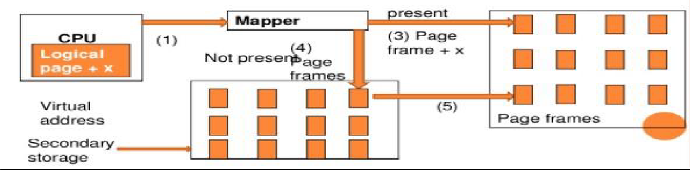

# How dose it works

In the modern world, virtual memory has become quite common these days. It is used whenever some pages require to be loaded in the main memory for the execution, and the memory is not available for those many pages.

So, in that case, instead of preventing pages from entering in the main memory, the OS searches for the RAM space that are minimum used in the recent times or that are not referenced into the secondary memory to make the space for the new pages in the main memory.

Let's understand virtual memory management with the help of one example.

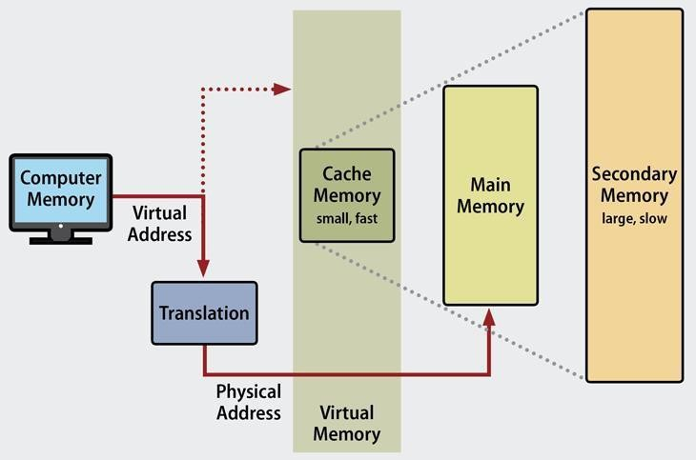

# Virtual Memory can be implemented via-

* + Demanding Paging
  + Demand Segmentation

# Demanding Paging

A demand paging mechanism is very much similar to a paging system with swapping where processes stored in the secondary memory and pages are loaded only on demand, not in advance.

# Bring page into memory only when it is needed

* Less I/O needed
* Less memory needed
* Faster response
* More users

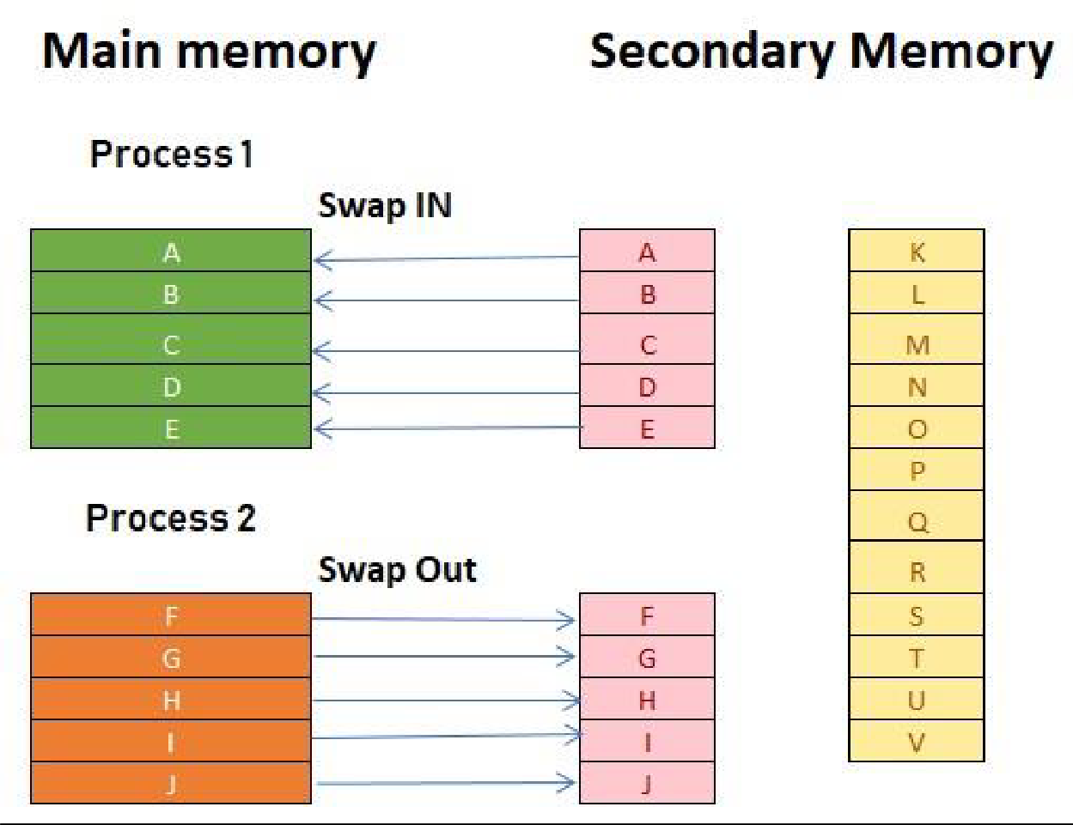

# Types of Page Replacement Methods

* + FIFO
  + Optimal Algorithm
  + LRU Page Replacement

**FIFO Page Replacement**

FIFO (First-in-first-out) is a simple implementation method. In this method, memory selects the page for a replacement that has been in the virtual address of the memory for the longest time.

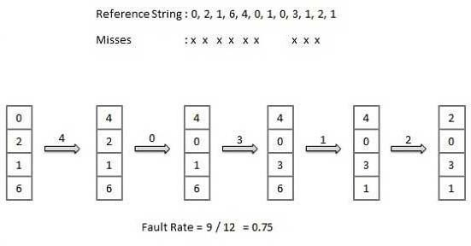

# Optimal Algorithm

The optimal page replacement method selects that page for a replacement for which the time to the next reference is the longest.

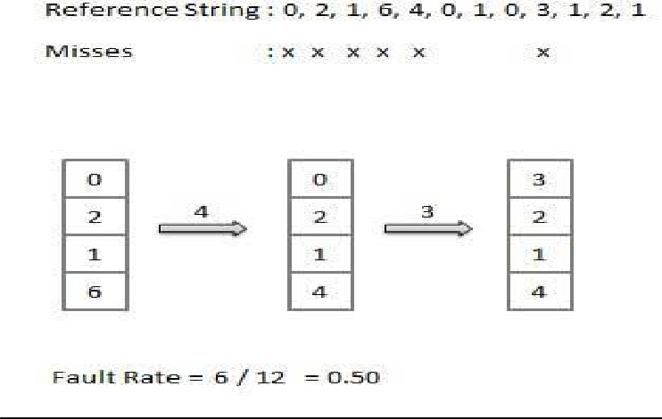

# LRU Page Replacement

The full form of LRU is the Least Recently Used page.

This method helps OS to find page usage over a short period of time. This algorithm should be implemented by associating a counter with an even- page.

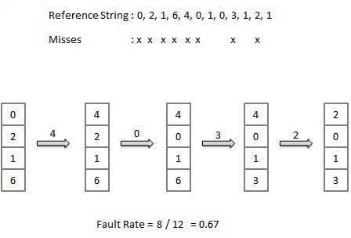

# Demand Segmentation

Demand segmentation is defined as the practice of analyzing demand data often divided into smaller sections (segments) to help measure performance or improve service levels.



# Advantages & Disadvantages of Virtual Memory

**Advantages:**

* + Virtual memory helps to gain speed when only a particular segment of the program is required for the execution of the program.
  + It allows you to run more applications at once.
  + It helps you to fit many large programs into smaller programs.
  + Data / code should be read from disk whenever required.

# Disadvantages:

* + Applications may run slower if the system is using virtual memory.
  + Likely takes more time to switch between applications.
  + Offers lesser hard drive space for your use.
  + It reduces system stability.

**CONCLUSION**

Virtual Memory is a storage mechanism which offers user an illusion of having a very big main memory. Virtual memory is needed whenever your computer doesn't have space in the physical memory. A demand paging mechanism is very much similar to a paging system with swapping where processes stored in the secondary memory and pages are loaded only on demand, not in advance. Important Page replacement methods are 1) FIFO 2) Optimal Algorithm 3) LRU Page Replacement. In FIFO (First-in-first-out) method, memory selects the page for a replacement that has been in the virtual address of the memory for the longest time. The optimal page replacement method selects that page for a replacement for which the time to the next reference is the longest.LRU

method helps OS to find page usage over a short period of time. Virtual memory helps to gain speed when only a particular segment of the program is required for the execution of the program. Applications may run slower if the system is using virtual memory.

Reference <https://en.wikipedia.org/wiki/Virtual_memory>

<https://www.tutorialspoint.com/operating_system/os_virtual_memory.htm> <https://www.studytonight.com/operating-system/virtual-memory>